1. EFLAGS register (Status/Control/System Flags)

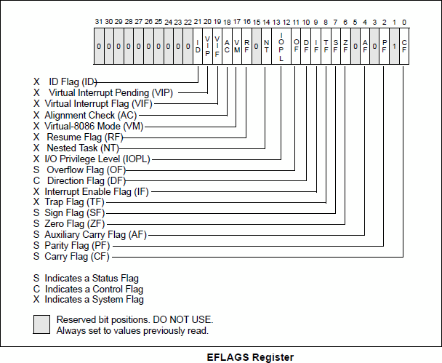

a. Status Flags
We can monitor the kind of result produced from the execution of arithmetic instructions by evaluating the status flags of the EFLAGS register.

There are 6 status flags defined in the following table:

Flag | Stands for | Meaning
CF | Carry Flag | CF is set to 1 if the result of unsigned number operation is out-of-range
OF | Overflow Flag | OF is set to 1 if the result of signed number operation is out-of-range
SF | Sign Flag | SF is set to 1 if the sign (i.e. leftmost, most significant) bit of the result is 1
ZF | Zero Flag | ZF is set to 1 if the result is equal to 0
PF | Parity Flag | PF is set to 1 if the rightmost (i.e. least significant) 8-bits of the result contain an even number of ones
AF | Auxiliary Flag | AF is set to 1 if there is a carry from the low nibble (lowest four bits) to the high nibble (upper four bits), or a borrow from the high nibble to the low nibble, in the rightmost (i.e. least significant) 8-bits of the result

2. Carry Flag (CF) and Overflow Flag (OF)

In unsigned arithmetic, watch the CF to detect errors. In signed arithmetic, the CF tells you nothing interesting.
In signed arithmetic, watch the OF to detect errors. In unsigned arithmetic, the OF tells you nothing interesting.

Operation | CF = 1 when: | Rules for CF | OF = 1 when: | Rules for OF
Addition | xxxxxxxx +  xxxxxxxx  1 0xxxxxxx | 1. The carry flag is set if the addition of two numbers causes a carry out of the most significant (leftmost) bits added.  Otherwise, the carry flag is turned off (CF = 0). | 0xxxxxxx +  0xxxxxxx  1xxxxxxx  1xxxxxxx +  1xxxxxxx  0xxxxxxx | 1. If the sum of two numbers with the sign bits off yields a result number with the sign bit on, the "overflow" flag is turned on. (adding two positives should be positive)  2. If the sum of two numbers with the sign bits on yields a result number with the sign bit off, the "overflow" flag is turned on. (adding two negatives should be negative)  Otherwise, the overflow flag is turned off (OF = 0).
Subtraction | 1 0xxxxxxx −  1xxxxxxx  1xxxxxxx | 2. The carry (borrow) flag is also set if the subtraction of two numbers requires a borrow into the most significant (leftmost) bits subtracted.  Otherwise, the carry flag is turned off (CF = 0). | 0xxxxxxx -  1xxxxxxx  1xxxxxxx  1xxxxxxx -  0xxxxxxx  0xxxxxxx | The subtraction rules are derived from addition rules above:  3. subtracting a negative is the same as adding a positive  4. subtracting a positive is the same as adding a negative  Otherwise, the overflow flag is turned off (OF = 0).
Multiplication | MUL and IMUL set CF=1 and OF=1 if the high octet/word of result is different from 0
Division | DIV and IDIV do not set the CF or OF !!!

3. INTEGER OVERFLOW
DIV and IDIV instructions will generate an INTEGER OVERFLOW exception (the program execution is stopped), if the quotient/remainder is larger than the register size.

DIV and IDIV do not set the CF or OF !!!

4. Sign Flag (SF)
Sign flag (SF) indicates the sign of the result:
- it is useful only when dealing with signed numbers
- it is simply a copy of sign bit (the most significant bit of the result)

5. Zero Flag (ZF)
Zero Flag (ZF) indicates zero result:
- if the execution of the last instruction has produced a zero result, then ZF=1
- otherwise, ZF=0

